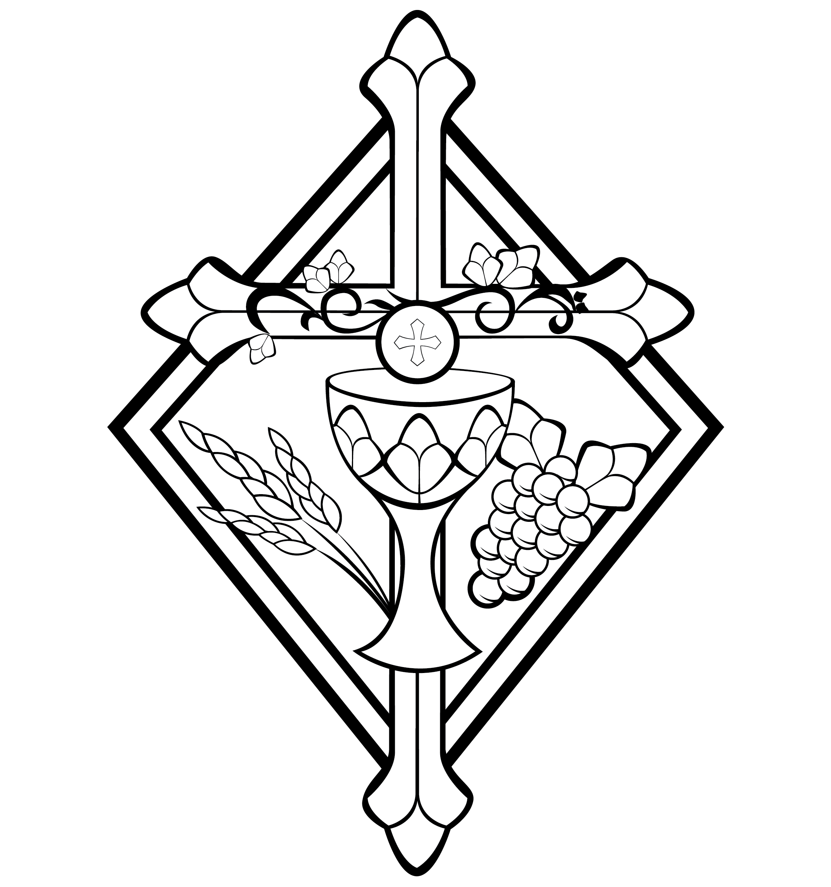
Maundy Thursday

CHRIST LUTHERAN CHURCH | Lodi, California
March 28, 2024

WELCOME TO WORSHIP
Welcome to Christ Lutheran Church. We pray that your soul will be strengthened by the good news about God’s grace, love, and forgiveness given to us. If you would like to learn more about our church, please speak with our pastor or one of our members after the service.
- Bathrooms are located in the fellowship hall. A changing table is located in the women’s bathroom.
WORSHIP THEME
Jesus took bread and a cup and gave them to his disciples. Such simple things. But in his words, he gives his disciples a view into a great mystery that has baffled many through the subsequent ages: “this is my body . . . this is my blood.”
The Israelites took the blood of lambs and marked their doors. On the outside it is at best a strange ritual, or at worst pagan superstition: to think that the blood of a lamb could somehow spare your house from the angel of death.
The mystery of the Sacrament is no less believable than the mystery of the Passover: in each meal, God gives a physical sign tied with the word of promise. In each, the people take and eat the one who won their deliverance. In each, God promises to work not because of what we’ve done, but because of his grace toward us.
As we begin our 3-day journey from the upper room, to the cross, and to the grave of our Lord, we meditate on this gift: the body and blood of our eternal Passover Lamb, given and shed for us.
The Common Service
The high and holy worship of God is faith in Jesus Christ. Such faith is created and sustained by God’s service to us (the German, “Gottesdienst,” “The Divine Service”). In the Divine Service, the Lord comes to us in His Word and Sacrament to bless and enliven us with His gifts. The Service is not something we do for God, but His service to us received in faith. The liturgy is God’s work. He gives, we receive.
HYMN Behold the Lamb of God | CW 101
INVOCATION
M: In the name of the Father, and of the Son ✙ and of the Holy Spirit
C: Amen.
CONFESSION
M: Brothers and sisters in Christ, in this Lenten season we have heard again how our Lord walked the path of suffering which led him to the cross for our salvation. We have also heard our Lord’s call to intensify our struggle against sin, death, and the devil—all that keeps us from loving God and one another. This is the struggle to which we were committed at Baptism; God’s forgiveness and the power of his Spirit to amend our lives continue with us because of his love for us in Jesus our Savior.
Within the family of the Church, God never wearies of giving peace and new life. In the absolution, we receive forgiveness as from God himself. We should not doubt this absolution but firmly believe that our sins are thus forgiven before God in heaven, for it comes to us in the name and by the command of our Lord.
We who receive God’s love in Jesus Christ are called to love one another, to be servants to each other, as Jesus became our servant.
In Holy Communion, first instituted on this night, the members of Christ’s body participate most intimately in his love. Remembering our Lord’s Last Supper with his disciples, we eat the bread and drink the cup of this meal. Together we receive the Lord’s gift of his body and blood for forgiveness and participate in that new covenant that makes us one with him and one another. The Lord’s Supper is the promise of the great banquet we will share with all the faithful when our Lord returns, the joyous culmination of our reconciliation with God and each other.
As we begin the solemn celebration of our Lord’s passion, let us confess our sins to him, receive his absolution, and be reconciled to God and each other in Christian love.
C: Holy God, gracious Father,
I am sinful by nature
and have sinned against you in my thoughts, words, and actions.
I have not loved you with my whole heart;
I have not loved others as I should.
I deserve your punishment both now and forever.
But Jesus, my Savior, paid for my sins
with his innocent suffering and death.
Trusting in him, I pray: God, have mercy on me, a sinner.

Silence for meditation and reflection
M: Our gracious Father in heaven has been merciful to us. He sent his only Son, Jesus Christ, who gave his life as the atoning sacrifice for the sins of the whole world. Therefore, as a called servant of Christ and by his authority, I forgive you all your sins in the name of the Father and of the T Son and of the Holy Spirit.
C: Amen.
M: Our Lord Jesus Christ has forgiven us, has reconciled us to God, and has promised us the power to forgive and love one another. Relying on his promise, therefore, be reconciled with one another.
C: Brothers and sisters, may the peace of Christ rule in our hearts, in our words, and in our actions.
PRAYER OF THE DAY
M: The Lord be with you.
C: And also with you.
M: Let us pray.
Lord Jesus Christ, in the Sacrament of Holy Communion you gave us your true body and blood as a remembrance of your suffering and death on the cross. May we firmly believe your words and promise, and always receive this Sacrament to our eternal good, for you live and reign with the Father and the Holy Spirit now and forever.
C: Amen
FIRST LESSON Exodus 12:21–30
The Lord institutes the Passover and delivers his people from slavery in Egypt.
²¹ Then Moses summoned all the elders of Israel and said to them, “Go at once and select the animals for your families and slaughter the Passover lamb. ²² Take a bunch of hyssop, dip it into the blood in the basin and put some of the blood on the top and on both sides of the doorframe. None of you shall go out of the door of your house until morning. ²³ When the Lord goes through the land to strike down the Egyptians, he will see the blood on the top and sides of the doorframe and will pass over that doorway, and he will not permit the destroyer to enter your houses and strike you down.

²⁴ “Obey these instructions as a lasting ordinance for you and your descendants. ²⁵ When you enter the land that the Lord will give you as he promised, observe this ceremony. ²⁶ And when your children ask you, ‘What does this ceremony mean to you?’ ²⁷ then tell them, ‘It is the Passover sacrifice to the Lord, who passed over the houses of the Israelites in Egypt and spared our homes when he struck down the Egyptians.’” Then the people bowed down and worshiped. ²⁸ The Israelites did just what the Lord commanded Moses and Aaron.
²⁹ At midnight the Lord struck down all the firstborn in Egypt, from the firstborn of Pharaoh, who sat on the throne, to the firstborn of the prisoner, who was in the dungeon, and the firstborn of all the livestock as well. ³⁰ Pharaoh and all his officials and all the Egyptians got up during the night, and there was loud wailing in Egypt, for there was not a house without someone dead.
SECOND LESSON 1 Corinthians 10:16,17
Christ is truly present as we participate in his body and blood.
¹⁶ Is not the cup of thanksgiving for which we give thanks a participation in the blood of Christ? And is not the bread that we break a participation in the body of Christ? ¹⁷ Because there is one loaf, we, who are many, are one body, for we all share the one loaf.
VERSE OF THE DAY 1 Corinthians 11:26
As often as you eat this bread and drink the cup, you proclaim the Lord’s death until he comes.
THE GOSPEL Mark 14:12–26
Christ institutes the Lord’s Supper.
¹² On the first day of the Festival of Unleavened Bread, when it was customary to sacrifice the Passover lamb, Jesus’ disciples asked him, “Where do you want us to go and make preparations for you to eat the Passover?”
¹³ So he sent two of his disciples, telling them, “Go into the city, and a man carrying a jar of water will meet you. Follow him. ¹⁴ Say to the owner of the house he enters, ‘The Teacher asks: Where is my guest room, where I may eat the Passover with my disciples?’ ¹⁵ He will show you a large room upstairs, furnished and ready. Make preparations for us there.”
¹⁶ The disciples left, went into the city and found things just as Jesus had told them. So they prepared the Passover.

¹⁷ When evening came, Jesus arrived with the Twelve. ¹⁸ While they were reclining at the table eating, he said, “Truly I tell you, one of you will betray me—one who is eating with me.”
¹⁹ They were saddened, and one by one they said to him, “Surely you don’t mean me?”
²⁰ “It is one of the Twelve,” he replied, “one who dips bread into the bowl with me. ²¹ The Son of Man will go just as it is written about him. But woe to that man who betrays the Son of Man! It would be better for him if he had not been born.”
²² While they were eating, Jesus took bread, and when he had given thanks, he broke it and gave it to his disciples, saying, “Take it; this is my body.”
²³ Then he took a cup, and when he had given thanks, he gave it to them, and they all drank from it.
²⁴ “This is my blood of the covenant, which is poured out for many,” he said to them. ²⁵ “Truly I tell you, I will not drink again from the fruit of the vine until that day when I drink it new in the kingdom of God.”

M This is the Gospel of the Lord.
C: Praise be to you, O Christ!

NICENE CREED
We believe in one God, Dt. 6:4
the Father, the Almighty, 2 Cor. 6:18
maker of heaven and earth, Is. 51:13
The Nicene Creed is the great Confession of the Christian faith professed by all Christians. The Creed originated at the First Council of Nicaea (c. AD. 325)
of all that is, seen and unseen. Col. 1:16
We believe in one Lord, Jesus Christ, 1 Cor 8:6
the only Son of God, Jn. 3:16
eternally begotten of the Father, Heb. 1:2,5
God from God, Light from Light, true God from true God, Jn. 1
begotten, not made, of one being with the Father. Jn. 10:30
Through him all things were made. Jn. 1:3
For us and for our salvation, 1 Th. 5:9
he came down from heaven, Jn. 6:38
was incarnate of the Holy Spirit and the virgin Mary, Lk. 1:35
and became fully human. Gal. 4:4

For our sake he was crucified under Pontius Pilate. Mk. 15:15
He suffered death and was buried. 1 Cor. 15:3-4a
On the third day he rose again in accordance
with the Scriptures. 1 Cor. 15:4b
The Creed itself was crafted as a confession of Scripture in opposition to the Arian heresy, which denied that the Lord Jesus and the Holy Spirit are God.

He ascended into heaven Ac. 2:33-34
and is seated at the right hand of the Father. Heb. 1:13
He will come again in glory Mt. 25:31
to judge the living and the dead, 2 Tim. 4:1
and his kingdom will have no end. Lk. 1:33
We believe in the Holy Spirit, the Lord, the giver of life, Job 33:4
who proceeds from the Father and the Son, Jn. 15:26
who in unity with the Father and the Son Jn. 4:24
is worshiped and glorified,
who has spoken through the prophets. 2 Pet. 1:25
We believe in one holy Christian Mt. 16:18; Eph. 2:19-20
and apostolic Church.
We acknowledge one baptism for the forgiveness of sins. Eph. 4:5; Ac. 2:38
We look for the resurrection of the dead 1 Cor. 15:21-22
and the life of the world to come. Amen. Rev. 22
HYMN OF THE DAY When You Woke That Thursday Morning| CW21 416
SERMON Exodus 12

OFFERING
In response to God’s love and forgiveness, we give back a portion of what he has given us. The members of Christ Lutheran Church have joined to proclaim the gospel to this community. These offerings support that work. While our guests are welcome to participate, they should not feel obligated to do so.

PRAYER OF THE CHURCH
M: Lord Jesus, you are the Lamb of God, pictured in the ancient Passover feast, now giving to us your own body and your own blood in Holy Communion. Hear our prayers as we come before you today.
For the deliverance of our souls, which are precious in God’s sight; and for confidence that Christ Himself prays with us, let us pray to the Lord:
C: Lord, have mercy.
M: In gratitude for the new testament in Christ’s blood, whose institution is celebrated this day among all peoples, that the world for which He died may know Him and His sacrifice, let us pray to the Lord:
C: Lord, have mercy.
M: For humility and selflessness according to the pattern of Christ, that in our vocations we would follow His example of self-sacrifice, let us pray to the Lord:
C: Lord, have mercy.
M: For all who are sick, that God would refresh, comfort and nourish them in the midst of the wilderness of this world, let us pray to the Lord:
C: Lord, have mercy.
M: For all who commune, that our Lord would receive us at His Holy Supper as He did the elders of Israel, not laying His hand on us, but counting us worthy to receive forgiveness, life and salvation, let us pray to the Lord:
C: Lord, have mercy.
M: For the Holy Church, gathered with saints and angels around the altar and throne of Christ, that we who taste this fellowship on earth may be brought at length to share it forever in eternal life, let us pray to the Lord:
C: Lord, have mercy.
M: Into Your hands, O Lord, we commend ourselves, our bodies and souls, and all things; redeem us, O Lord, faithful God; through Jesus Christ, Your Son, our Lord, who lives and reigns with You and the Holy Spirit, one God, now and forever.
C: Amen.

LORD’S PRAYER Matthew 6:9-13; Luke 11:2-4
C: Our Father, who art in heaven,
hallowed be thy name,
thy kingdom come,
thy will be done on earth as it is in heaven.
Give us this day our daily bread;
and forgive us our trespasses,
as we forgive those
who trespass against us;
and lead us not into temptation,
but deliver us from evil.
For thine is the kingdom
and the power and the glory
forever and ever. Amen.

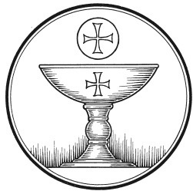
The Service of the Sacrament
This greeting marks a new service, so to speak. These ancient introductory words & phrases help to highlight, celebrate and bring attention to the Sacrament.
M: The Lord be with you.
C: And also with you.
M: Lift up your hearts.
C: We lift them up to the Lord.
M: Let us give thanks to the Lord our God.
C: It is good and right so to do.
M: It is truly good and right that we should at all times and in all places give you thanks, O Lord, holy Father, almighty and everlasting God, through Jesus Christ, our Lord, who loved his own who were in the world—and loved them to the end; who on the night before he suffered instituted this holy Sacrament; that we, receiving the benefits of his passion and resurrection, by partaking of his Body and Blood. Therefore with all the saints on earth and hosts of heaven, we praise your holy name and join their glorious song:

HOLY, HOLY, HOLY – Sanctus
C: Holy, holy, holy Lord God of heavenly hosts:
heav’n and earth are full of your glory.
Hosanna, hosanna, hosanna in the highest!
Blessed is he, blessed is he, blessed is he who comes in the name of the Lord.
Hosanna, hosanna, hosanna in the highest.
WORDS OF INSTITUTION Matthew 26, Mark 14, Luke 22
M: Our Lord Jesus Christ, on the night he was betrayed, took bread; and when he had given thanks, he broke it and gave it to his disciples, saying: “Take and eat. This is my ✙ body, which is given for you. Do this in remembrance of me.”
The Words of institution both proclaim the words of Jesus to the congregation and sets apart the bread and wine for the Lord’s Supper.
Then he took the cup, gave thanks, and gave it to them, saying, “Drink from it all of you; this is my ✙ blood of the new covenant, which is poured out for you for the forgiveness of sins. Do this, whenever you drink it, in remembrance of me.”
PEACE OF THE LORD – Pax Domini John 20:19
M: The peace of the Lord be with you always.
C: Amen

O CHRIST, LAMB OF GOD – Agnus Dei John 1:29
C: O Christ, Lamb of God,
you take away the sin of the world;
have mercy on us.
O Christ, Lamb of God,
you take away the sin of the world;
have mercy on us.
O Christ, Lamb of God,
you take away the sin of the world;
Grant us your peace. Amen.

DISTRIBUTION
Those who will be receiving Holy Communion today may wish to read Personal Preparation for Holy Communion, found on page 156 in the front section of the hymnal. This page helps us put into practice what the Bible encourages: “Everyone ought to examine themselves before they eat of the bread and drink from the cup.” (1 Corinthians 11:28)
Christ Lutheran Church confesses and practices the Biblical teaching of a Closed Communion. We ask that only members of the Wisconsin Synod [WELS] or the Evangelical Lutheran Synod [ELS] join us at the Lord’s Table. If you have questions concerning our communion practice, or would like to inquire about how you, too, can commune with us, please speak with the Pastor following the service.

HYMN OF PRAISE Here, O My Lord, I See You Face to Face| CW 315
M: We give thanks, almighty God, that you have refreshed us with this holy supper. We pray that through it you will strengthen our faith in you and increase our love for one another. We ask this in the name of Jesus Christ, our Lord, who lives and reigns with you and the Holy Spirit, one God, now and forever.
C: Amen.
CLOSING HYMN Go To Dark Gethsemane| CW 104
During the hymn, the Communion Vessels are removed in preparation of the stripping of the altar.

THE STRIPPING OF THE ALTAR
The altar is solemnly stripped in token of the Lord’s abandonment by his disciples and in preparation of Good Friday. During the stripping of the altar, the congregation may meditate on the words of Psalm 88.

Psalm 88

¹Lord, you are the God who saves me;
day and night I cry out to you.
²May my prayer come before you;
turn your ear to my cry.
³I am overwhelmed with troubles
and my life draws near to death.
⁴I am counted among those who go down to the pit;
I am like one without strength.
⁵I am set apart with the dead,
like the slain who lie in the grave,
whom you remember no more,
who are cut off from your care.
⁶You have put me in the lowest pit,
in the darkest depths.
⁷Your wrath lies heavily on me;
you have overwhelmed me with all your waves.
⁸You have taken from me my closest friends
and have made me repulsive to them.
I am confined and cannot escape;
⁹my eyes are dim with grief.
I call to you, Lord, every day;
I spread out my hands to you.
¹⁰Do you show your wonders to the dead?
Do their spirits rise up and praise you?
¹¹Is your love declared in the grave,
your faithfulness in Destruction?
¹²Are your wonders known in the place of darkness,
or your righteous deeds in the land of oblivion?
¹³But I cry to you for help, Lord;
in the morning my prayer comes before you.
¹⁴Why, Lord, do you reject me
and hide your face from me?
¹⁵From my youth I have suffered and been close to death;
I have borne your terrors and am in despair.
¹⁶Your wrath has swept over me;
your terrors have destroyed me.
¹⁷All day long they surround me like a flood;
they have completely engulfed me.
¹⁸You have taken from me friend and neighbor—
darkness is my closest friend.

The minister exits in silence.

Worshipers may remain for prayer and meditation before dispersing quietly.

